**CLOUD SQL**

Cloud SQL in Google Cloud Platform (GCP) is a fully-managed database service that allows users to set up, maintain, manage, and administer relational databases on the cloud. It supports popular database engines, including:

* **MySQL**: An open-source relational database known for its speed and reliability.
* **PostgreSQL**: An advanced open-source database known for its robustness and support for complex queries.
* **SQL Server**: A relational database management system from Microsoft, known for its integration with other Microsoft services.

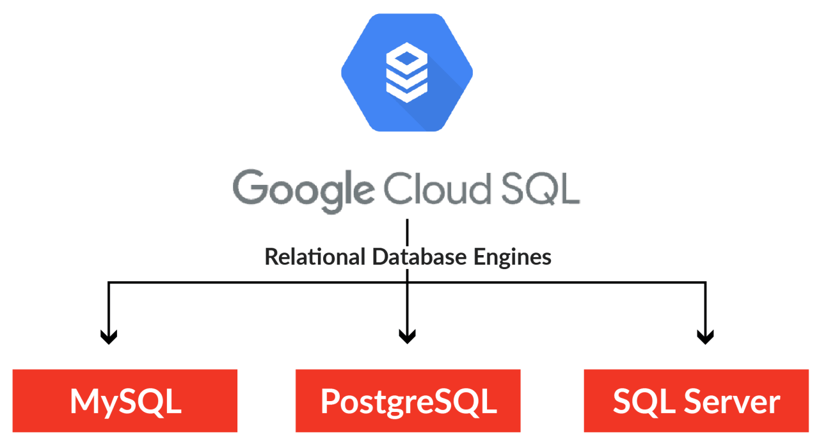

**Key Features of Cloud SQL:**

1. **Fully Managed**:
   * **Automatic Backups**: Regular automated backups help protect data and enable point-in-time recovery.
   * **Automatic Updates**: System and security updates are handled automatically to ensure the database is up-to-date.
   * **High Availability**: Options for automatic failover and replication to ensure minimal downtime and high availability.
2. **Scalability**:
   * **Vertical Scaling**: Easy to resize instances to handle increased workloads by adjusting CPU, memory, and storage.
   * **Horizontal Scaling**: Support for read replicas to distribute read queries and improve performance.
3. **Security**:
   * **Data Encryption**: Encrypts data at rest and in transit to protect sensitive information.
   * **Access Controls**: Integrates with Identity and Access Management (IAM) for granular access control and authentication.
   * **Private IPs**: Supports private IP addresses for secure communication within your VPC (Virtual Private Cloud).
4. **Integration**:
   * **Seamless Integration**: Works well with other GCP services such as Google Compute Engine, Google App Engine, and Google Kubernetes Engine.
   * **Data Import/Export**: Tools and features to easily migrate data into and out of Cloud SQL.
5. **Monitoring and Maintenance**:
   * **Cloud Monitoring**: Provides monitoring and alerts for database performance metrics and operational health.
   * **Logs and Insights**: Access to logs and insights for debugging and performance tuning.
6. **Cost Management**:
   * **Pay-as-You-Go**: Flexible pricing based on the instance size, storage, and usage, with no upfront costs.

